Segundo Desafio

Felipe Israel Corrêa

**VHDL**

library IEEE;

use IEEE.std_logic_1164.all;

entity prior_detect is

port(

P0, P1, P2, P3 : in bit;

X0, X1, INT : out bit

);

end prior_detect;

architecture nv_logic of prior_detect is

begin

process (P0, P1, P2, P3)

begin

if (P0 = '1') then

X0 <= '0';

X1 <= '0';

INT <= '1';

elsif (P1 = '1') then

X0 <= '1';

X1 <= '0';

INT <= '1';

elsif (P2 = '1') then

X0 <= '0';

X1 <= '1';

INT <= '1';

elsif (P3 = '1') then

X0 <= '1';

X1 <= '1';

INT <= '1';

else

X0 <= '1';

X1 <= '1';

INT <= '0';

end if;

end process;

end nv_logic;

**RPL**

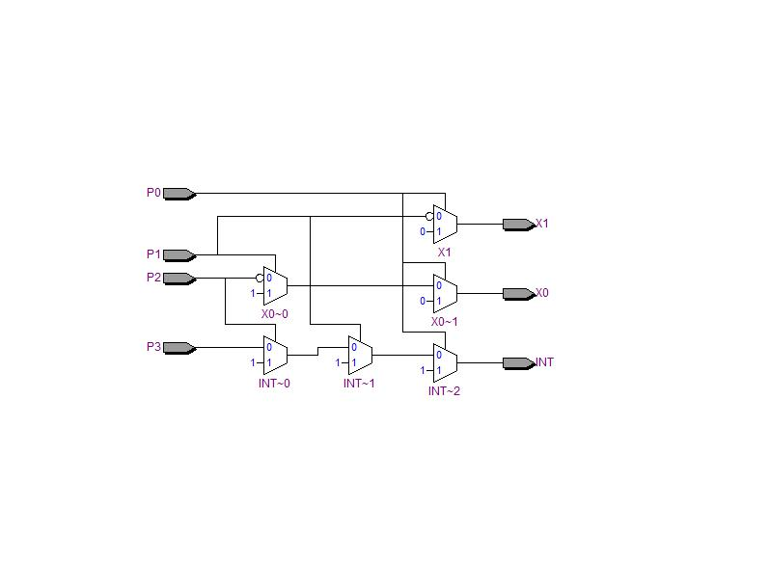

**Sim waveform**

